

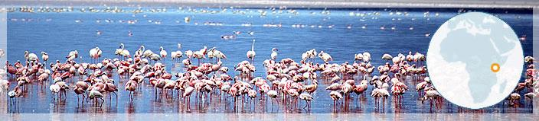

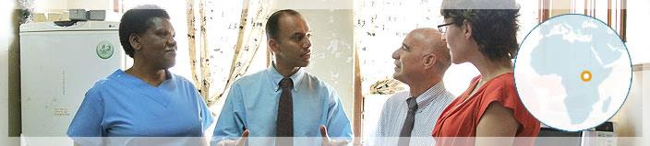

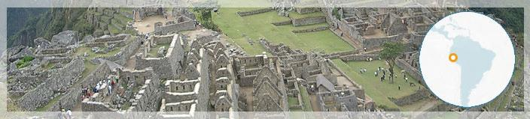

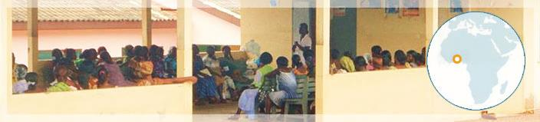

TABLE OF CONTENTS  
  
Welcome4

About the Program5

Program Introduction by Dr. Roger I. Glass; Director, Fogarty International Center5

**Fellows & Scholars Program7**

Our Consortium7

**Support Staff10**

Support Center10

**International Institutional Partner Directors12**

**Roles & Expectations14**

Expectations of Trainees14

Expectations of the Home Institution & Support Center Staff14

Expectations of the International Site15

**Orientation15**

**Professional Misconduct15**

Scientific Misconduct15

Dismissal Policy16

**Compliance16**

Human Subjects Training16

**Funding16**

Stipends16

Supplementing Stipends16

Research Funds17

Tuition17

Language Courses17

Computer Policy17

**Vaccinations, Prophylaxis, & Health Exams18**

**Housing18**

**Insurance18**

Equipment Insurance18

Emergency Insurance18

Medical Insurance18

Continuing Medical Coverage from Current Appoint19

Malpractice Insurance19

**Publications & Acknowledging Funding19**

**Research Administration20**

Administrative Procedures20

Research Preparation20

Epidemiological Consultation20

**Special Requests20**

**Taxes21**

**Travel 21**

Business Travel21

Personal Travel21

Purchasing Travel21

Returning to the US during the Fellowship Year21

Fly America Act21

Coach Airfare21

Excess Baggage22

**Flights22**

**Visas & Passports22**

**Safety & Emergency Policies22**

Motorcycles and Vehicles22

Purchasing a Vehicle22

Contingency Plans in Emergency Situations during the Training Year22

Evacuation23

**Emergency Calling Tree24**

**Alumni Affairs25**

CareerTrac25

Social Networking25

**Resources25**

Books25

Adobe Connect Trainings26

Program Website28

**WELCOME**

Welcome to the Northern Pacific Global Health Fellowship Program. We’re delighted you will be joining us for what we hope is a transformative experience that solidifies your interest in global health, sharpens your research skills and provides a unique opportunity to forge collaborative relationships and friendships that may last a lifetime. The success of our Program is based upon your success. We believe close attention to developing a mentoring team will help you develop a project that allows you to build upon your passions and set the cornerstone for a career in global health.

Our international partnerships are a particular strength of our program and in most cases span decades. These collaborations will provide the perfect setting for you to experience the excitement and intricacies of global health research in a supportive environment. We look forward to participating in your success!

Sincerely,

|  |  |
| --- | --- |
| **Chandy C. John, MD**  Professor  Departments of Pediatrics & Medicine  University of Minnesota | **Joseph C. Kolars, MD**  Senior Associate Dean  Education & Global Initiatives  University of Michigan |
| **Vivek R. Nerurkar, PhD**  Professor & Chair  Department of Tropical Medicine  University of Hawaii | **Joseph R. Zunt, MD, MPH**  Professor  Departments of Neurology & Global Health  University of Washington |

**ABOUT THE PROGRAM**

**Program Introduction by Dr. Roger I. Glass; Director, Fogarty International Center**

**Building the next generation of global health leaders**

*"We cannot always build the future for our youth, but we can build our youth for the future."*

*~Franklin D. Roosevelt*

I'm inspired by these wise words from America's 32nd President. One of my favorite activities as Fogarty director is having the opportunity each summer to meet with some of the rising stars who will become our future global health leaders. Each July I delight in speaking with these early-career doctors, dentists, scientists and veterinarians during our Fogarty Fellows and Scholars Orientation here on the NIH campus. I find it invigorating to interact with them and witness your passion, idealism and commitment to improving the health of all of the world's people.

Your youthful enthusiasm is intoxicating and causes me to pause and reflect on my own career in global health. It serves as a reminder of why I decided, all those years ago, to travel to Bangladesh to study the terrible water-borne viruses that are such vicious killers, particularly of children.

I cannot overstate the impact a research Fellowship in a developing country can have on an early-career scientist. The experience gives them firsthand exposure to difficult issues on the ground, while providing the opportunity to forge relationships and scientific collaborations that can boost your career trajectory and lead to a lifetime of global health accomplishments.

It's appropriate in this season of renewal that we're entering the next phase of Fogarty's Global Health Program for Fellows and Scholars, one that we believe will strengthen the quality of mentorship and will broaden the research topics studied, to more fully represent the diversity of the global health challenges we face.

I'm delighted to announce that we're awarding about $20.3 million over five years to enhance and expand this effort. By forming a network of 20 U.S. academic institutions with substantial experience in global health research, I'm confident our alumni will be well-equipped to succeed in the global arena and become the next generation of global health leaders.

With the rising tide of developing-country deaths from chronic, non-communicable diseases, it's vital that we develop scientific expertise in a wider span of health problems, from genetics to geriatrics, from cancer and diabetes to heart disease. At the same time, we must continue to build capacity in the longstanding global health topics of HIV/AIDS, malaria and TB. We must broaden our net to recruit early-career dentists, cardiologists, oncologists, neurologists, behavioral scientists, engineers, health economists and others who can help us address the full range of global health needs.

Since 2004, more than 500 Fogarty Fellows and Scholars have been supported on one-year mentored clinical research experiences at 28 top-ranked research sites in 15 countries. In 2010, the Fulbright Program formed a partnership with Fogarty, joining more than a dozen NIH Institutes and Centers in supporting the Fellows and Scholars initiative.

From these modest investments, we have seen great returns. Participants have published more than 300 articles in peer-reviewed journals and have presented research findings at numerous scientific meetings. Many have remained engaged in specific research questions important to your host countries long after the Fellowships have ended - developing toolkits, starting charities to provide funding and continuing to share your expertise from afar. Several alumni have already secured independent NIH funding to continue your global health studies, one of our highest measures of success.

I look forward to meeting the next class of Scholars and Fellows as they embark on your research training experiences. While we continue to "build our youth for the future," my hope is that it will be a future that offers a long and healthy life for all the world's people

Source: [http://www.fic.nih.gov/News/GlobalHealthMatters/mar-apr-2012/Pages/fellows- scholars-roger-glass.aspx](http://www.fic.nih.gov/News/GlobalHealthMatters/mar-apr-2012/Pages/fellows-%20scholars-roger-glass.aspx)

**FELLOWS & SCHOLARS PROGRAM**

To help foster the next generation of global health scientists, the Fogarty International Center and its partners at the National Institutes of Health have funded five consortia of universities to administer 11-month clinical research-training programs. This new program replaces the Fogarty International Clinical Research Scholars and Fellows Program (FICRS-F).

The objective of our consortium is to provide outstanding mentored research training to post- doctorate trainees and doctoral students in seven different countries.

NIH institutes supporting the program include the Eunice Kennedy Shriver National Institute of Child Health and Human Development (NICHD), National Cancer Institute (NCI), National Eye Institute (NEI), National Heart, Lung, and Blood Institute (NHLBI), National Institute of Allergy and Infectious Diseases (NIAID), National Institute of Arthritis and Musculoskeletal and Skin Diseases (NIAMS), National Institute of Biomedical Imaging and Bioengineering (NIBIB), National Institute of Dental and Craniofacial Research (NIDCR), National Institute of Diabetes and Digestive and Kidney Diseases (NIDDK), National Institute on Drug Abuse (NIDA), National Institute of General Medical Sciences (NIGMS), National Institute of Mental Health (NIMH), National Institute of Neurological Disorders and Stroke (NINDS), National Institute of Nursing Research (NINR), Office of AIDS Research (OAR), Office of Research on Women’s Health (ORWH), and Office of Behavioral and Social Sciences Research (OBSSR)

**Our Consortium**

The Northern Pacific Global Health Research Fellows Training Consortium is a partnership between the Universities of Washington, Hawai’i, Michigan and Minnesota; with international academic partnerships in Kenya, Uganda, Ghana, Cameroon, Peru, Thailand and China.

**- Four Co-PIs collectively manage the consortium -**

|  |  |
| --- | --- |
| http://depts.washington.edu/daid/images/zuntres.jpg  **Co-PI: Joseph Zunt, MD, MPH**  University of Washington  Professor of Neurology Global Health, Medicine (Infectious Diseases) & Epidemiology | **Email:** jzunt@uw.edu   * **Academic Interests:** Infections of the nervous system, sexually transmitted infections, slum health * **Primary Countries of Collaboration:** Peru * **Years in Research:** 17 * **First Job:** My first paid job was as a babysitter; my first true paycheck was during high school when I worked at York Steak House at Ridgedale Mall in Minneapolis – from busboy to dishwasher to chef. I like global health work much more than that job! * **Hobbies:** Tinkering with broken machines and motors, gardening, running, cooking, and reading (I read about one book a week). * **Advice for Trainees:** Be efficient: use your project protocol as a template for your IRB application, for your abstract, for an oral presentation, for the manuscript – then for your grant proposal. |

|  |  |
| --- | --- |
| MEDPEDS2 - Image - 180x222 - Chandy John  **Co-PI: Chandy John, MD, MS**  University of Minnesota  Professor of Pediatrics & Medicine and Director of the Division of Global Pediatrics | * **Email:** ccj@umn.edu * **Interests:**   + Clinical: malaria, pediatric infectious diseases   + Research: malaria immunology and epidemiology, pathogenesis of severe malaria, interactions between infection, nutrition and child neurodevelopment Education: global health training for graduate students, medical students, residents and fellows; global health tracks in pediatrics residencies; mentorship * **Years in research:** 18 * **First job:** Newspaper delivery boy * **Hobbies:** Reading, writing, music, theater, hiking, travel * **Advice for Trainees:** Find something you love to do that will also make life better for others, and then do that thing. Don't  compare: there will always be people who do things better or worse than you. Focus on making sure your work is excellent and relevant, and keep learning, always. The most enjoyable thing about research (besides the joy of making a positive difference for others) is that you will always be learning. That is also the most humbling thing about research. |

|  |  |
| --- | --- |
| http://www.med.umich.edu/globalreach/siteparts/images/articles_kolars.jpg  **Co-PI: Joseph C. Kolars, MD**  University of Michigan  Senior Associate Dean of Education & Global Initiatives Institute (JI) for Clinical and Translational Research | * **Email:** jckolars@umich.edu * **Academic Interests:**    + Medical education and research systems in low-resource settings   + Aligning education with desired improvements in health   + The assessment of competency   + Collaborating across cultures   + Gastrointestinal diseases in low-resource settings * **Primary Countries of Collaboration:** China and Ghana * **Years in Research:** 24 * **First Job:** Paperboy! And then a quick ascendency through the fast-food industry. * **Hobbies:** Sailing, bicycling, and in-line skating. * **Advice for Trainees:** Dream big and have a passion for an area. But think incrementally for your first projects with very defined, reachable goals that can be reasonably achieved in a short time frame. |

|  |  |
| --- | --- |
| http://www5.pbrc.hawaii.edu/rcmi/img/nerurkar.jpg  **Co-PI: Vivek R. Nerurkar DMLT, MSc, PhD**  University of Hawaii  Professor and Chair, Department of Tropical Medicine, Medical Microbiology and Pharmacology (TMMMP), and Director, Technical Core, Centers for Biomedical Research Excellence (COBRE) | * **Email:** * **Academic Interests:**    + Conduct research, training and teaching.   + Educating the disadvantaged and minorities. * **Years in Research:** 31 * **First Job:** Delivering milk at 5:30 AM! * **Hobbies:** Gardening, reading world literature, understanding various religions, history and geography, listening to news NPR/CNN/BBC etc., traveling, conducting research and teaching! * **Advice for Trainees:** Publish or perish and Perseverance. |

**SUPPORT STAFF**

**Support Center**

The Northern Pacific Support Center is housed at the University of Washington in Seattle, WA. The Support Center oversees overall program management, including: information dissemination and applicant selection, communications, program coordination and logistics, program monitoring and evaluation, organization of educational programs and conferences, and maintaining relationships with program alumni.

|  |  |
| --- | --- |
| **Nicole Hobbs**  Program Manager | * **Phone:** 206-897-6005 * **Email:** hobbsn@uw.edu * **Duties:** Overall Program Management * **First Job:** A server at a retirement home and then a manager of an ice cream store! * **Hobbies**: Thrift shopping, cooking, rowing, and outdoor adventures! * **Advice for Trainees:** Don’t panic if something doesn’t go as planned; in Global Health things work themselves out within a day or two. |

|  |  |
| --- | --- |
| **Mallory Erickson**  Program Coordinator | * **Phone:** 206-221-8940 * **Email:** emallory@uw.edu * **Duties:** Program Support * **First Job:** Volunteering at the Pacific Science Center * **Hobbies**: Photography, jewelry making, traveling to Nicaragua * **Advice for Trainees:**  Living abroad requires patience and a great sense of humor. Try to appreciate all of the wonderful things the country has to offer, even during the most frustrating moments. |

|  |  |
| --- | --- |
| **Yolanda Thomas, MPA**  Program Consultant | * **Phone:** 301-203-1090 * **Email:** ythomas@ficrsconsultant.com * **Duties:** Application management, orientation planning, event logistics * **First Job:** A student position at the Florida Department of Education * **Hobbies**: Traveling, photography, and spending time with my family * **Advice for Trainees:** Surround yourself with a great support system |

|  |  |
| --- | --- |
| MEDPEDSGLOBAL2 - Image - 70x80 - Molly McCoy  **Molly McCoy, MA**  University of Minnesota  Program Manager | * **Phone:** 612-624-9749 * **Email:** mccoy019@umn.edu * **Duties:** Program support for U of MN trainees (i.e. making sure trainees get paid their stipends) * **First Job:** Car-hop at a drive‐in diner in my hometown (no, I didn’t wear roller skates but I certainly would have liked to) * **Hobbies**: Traveling, tennis, running, and learning how to parent my daughter who was born in May 2012 * **Advice for Trainees:** Make the most of every moment |

**INTERNATIONAL INSTITUTIONAL PARTNER DIRECTORS**

You will have a point-of-contact in the country of training to ensure they are received at the airport, have proper housing, are introduced to the local mentoring team and are registered with the U.S. Embassy. Partner directors will coordinate pairing of trainees with mentors, ensure mentorship is meeting goals, facilitate mentor training sessions in your country, review trainees’ pilot projects and interact closely with program directors to discuss development of research, mentoring and infrastructure. They will also serve as the first point-of-contact if emergent situations arise.

**Peru: Silvia M. Montano, MD, MPH**, Professor of Neurology, UNMSM and Affiliate Assistant Professor in the UW Department of Neurology, Dr. Montano received her MPH at the UW and has collaborated with Dr. Zunt in neuroepidemiologic research of retroviral infections, epilepsy and neurocysticercosis since 1996. She has been co-director of the UW-Peru site for the NIH Fogarty/Ellison and FICRS-F Programs, has co-directed all UW-sponsored medical student and resident elective activities in Peru, and will be the co-director of the UW-Peru Fulbright/Fogarty Fellowship Program.

**Kenya: John Kinuthia, MBChB, MMed, MPH**, an obstetrician/gynecologist at Kenyatta National Hospital and Honorary Lecturer at the UON, Dr. Kinuthia received his MPH degree from the UW in 2009 after completing an assessment of barriers to PMTCT intervention uptake in Western Kenya. Prior to initiating his MPH, Dr. Kinuthia was the Nairobi-site Study Coordinator for a multi-site clinical trial of HSV-2 suppression to prevent heterosexual HIV-1 transmission among HIV-discordant couples. Dr. Kinuthia has been the Kenya director for the NIH FICRS-F Programs and will be co-director of the UW-Kenya Fulbright/Fogarty Fellowship Program.

**Ghana: Peter Donkor, BDS, MS, MDSc**, Pro-Vice Chancellor at Kwame Nkrumah University of Science and Technology in Kumasi, Ghana, and Aaron Lawson, MBChB, PhD, Provost of the College of Health Sciences at the University of Ghana in Accra will serve as site coordinators for Ghana, coordinating placements of fellows and scholars at your respective universities. Both individuals have collaborated with UM for many years, are experienced mentors, collaborate on the Ghana-Michigan PARTNER training grant, and serve as co- Investigators on UM’s recent Gates Foundation grant to address Human Resources for Health in Ghana.

**Uganda: Sarah Kiguli, MBChB, MMed**, Head, Department of Pediatrics and Child Health, Makerere University and Mulago Hospital, is co-investigator on the large MEPI grant and supplement awarded to a consortium of Ugandan universities (Medical Education for Equitable Services for All Ugandans [MESAU], PI, Nelson Sewankambo). She was also co-PI for the Fluid Expansion As Supportive Therapy (FEAST) study, the results of which were recently published in the New England Journal of Medicine, and she is co-investigator on Dr. John’s FIC D43 training grant on infection and neurodevelopment. Dr. Kiguli is a leader in medical education in Uganda, and will supervise and coordinate fellow education in Uganda. Additional faculty who currently partner with University of Minnesota or University of Washington will also work as mentors for this training grant, including Dr. Richard Idro, Dr. Robert Opoka, and Dr. Moses Joloba.

**Thailand: Jintanat Ananworanich, MD, PhD**, Chief, of the SEARCH Collaboration in Thailand, is active in HIV/AIDS research and training in the South East Asia with the University of Hawaii, the Thai Red Cross AIDS Research Centre in Bangkok and The Armed Forces Research Institute of the Medical Sciences (AFRIMS), also in Bangkok, Thailand. Dr. Ananworanich has served as a mentor for all of these institutions.

**China: Yangfeng Wu, MD, PhD** is Professor of Epidemiology, Peking University School of Public Health Executive Director for the George Institute for Global Health, Executive Associate Director of the Peking University Clinical Research Institute, and Executive Board Member of the University of Michigan-Peking University Health Science Center Joint Institute for Clinical and Translational Research. He is PI of the NHLBI-funded Global Health Activities in Developing Countries to Combat Non-Communicable Chronic Cardiovascular and Pulmonary Diseases and Co-PI on the NIH Fogarty International Center-funded Millennium Promise Award “Training for Prevention and Treatment of Stroke in China”.

**Cameroon:** Information coming soon.

**ROLES & EXPECTATIONS**

**Expectations of Trainees:**

* Fellows and Scholars are required to spend at least 11 consecutive months at their international research site. If extenuating circumstances arise, the individual may request an exemption by contacting the Support Center and detailing the specifics of the situation and request for exemption.
* Trainees will work on a research project and contribute to the research productivity of the site and education of their peers and other trainees.
* Trainees will work within the boundaries of their training and within the research areas agreed upon by them and their mentorship team. Changes to a research plan will be discussed in advance with their primary mentor and documented in writing.
* Trainees are responsible for ensuring research activities comply with US and international rules and regulations regarding conduct of research with human subjects or animals.
* Trainees will acknowledge the Consortium, the Fogarty International Center, as well as other NIH co-funders, in all publications and presentations deriving from the Fellowship year.
* Trainees are responsible for maintaining contact with the Support Center for 20 years following their Fellowship year and will participate in follow-up surveys and requests for information.
* Fellows and Scholars will reply to emails and phone calls promptly and will communicate any problems and successes with their mentorship team and the Support Center.
* Trainees will complete Core Competency curriculum assignments in a timely manner and report any delays to their mentorship team.
* Trainees will be required to follow institutional guidelines regarding purchasing and securing travel arrangements. Failure to comply with institutional guidelines could result in expenses being deemed unallowable.

**Expectations of the Home Institution & Support Center Staff:**

* Staff will coordinate logistics of the Fellowship, including: purchase of research materials for trainees, stipend payments, travel, and other administrative needs of the program.
* Staff will educate trainees on administrative and financial rules and regulations of the Fellowship.
* Support Center staff will inform trainees of the IRB policies at their institution and will provide trainees with IRB documents to complete.
* Staff will communicate program information in a timely manner to all Fellows and Scholars.
* Support Center staff will serve as a point-of-contact for issues that arise while a trainee is abroad. Support Center staff will keep trainees apprised of travel warnings.
* Staff will track trainee career advancements and maintain contact with you for 20 years following the Fellowship.

**Expectations of the International Site:**

* International staff will educate trainees about the policies and procedures that are specific to the site, including safety and security.
* International site contacts will help trainees obtain office/lab space.
* International staff will communicate any problems or concerns with domestic PIs in a timely manner.

**ORIENTATION**

All trainees are required to attend the NIH Orientation in July. The meeting planner will book travel arrangements and trainees should not book their own transport unless they receive prior approval from the Program Manager.

Reimbursement requests for additional expenses (not covered by per diem or ground transport allowances) will not be approved.

If a trainee incurs additional expenses by upgrading their room or purchasing items above the per diem allotment, they are personally responsible for the expenses and they will not be reimbursed.

If a trainee must arrive late or depart early from Orientation, they must notify the Program Manager and meeting planner as early as possible.

**PROFESSIONAL MISCONDUCT**

**Scientific Misconduct**

Scientific misconduct is the violation of the standard codes of scholarly conduct and ethical behavior in professional scientific research.

*Danish definition*: "Intention or gross negligence leading to fabrication of the scientific message or a false credit or emphasis given to a scientist"

*Swedish definition*: "Intentional distortion of the research process by fabrication of data, text, hypothesis, or methods from another researcher's manuscript form or publication; or distortion of the research process in other ways."

The consequences of scientific misconduct can be damaging for both perpetrators and any individual who exposes it. In addition there are public health implications attached to the promotion of medical or other interventions based on dubious research findings.

("Scientific Misconduct." Wikipedia. Wikimedia Foundation, 09 May 2013. Web. 05 Sept. 2013.)

**Dismissal Policy**

If a trainee participates in scientific or professional misconduct, the Consortium Directors and relevant supervisors will meet with them to discuss the issue and attempt to rectify the situation. If no clear resolution is found, the Support Center could terminate the award and dismiss the trainee from the program.

**COMPLIANCE**

**Human Subjects Training**

All trainees are required to complete human subjects training in person or online (CITI) before leaving the country or before their start date (for international trainees). Please reference the RCR/IRB tab for procedures.

**FUNDING**

**Stipends**

Stipends will be paid from the US institution affiliated with the international training institution where the trainee will be hosted and will begin two weeks after the start date of their training or in accordance with the US institution’s payroll schedule.

Each US Scholar will receive a stipend of $20,000 USD and each US Fellow will receive a stipend of $45,000 USD. Stipend amounts for international trainees are based on corresponding salaries for researchers within their home country.

Additional funds for housing, telecom (cell phones, internet at home, etc.) or daily travel will not be provided. As a result, trainees are expected to utilize their stipends for these personal expenses during their 11-month research period.

No exceptions will be made for higher stipends from the Support Center.

**Supplementing Stipends**

The stipend for the fellowship is determined by NIH guidelines and trainees will not receive more than the listed stipend from the fellowship. However, trainees are allowed to receive additional stipend support from other non-federal sources as allowed by NIH guidelines.

If trainees receive additional support for the stipend, they must notify the Program Manager to ensure that they are in compliance with NIH policies.

**Research Funds**Each trainee will receive a pre-determined amount of research funds based on available funds from NIH and mentors. These awards should be spent in accordance with NIH guidelines on allow ability and accountability. Trainees should follow these basic guidelines:

* Develop a budget prior to beginning the fellowship.
* Request prior approval of expenses over $100 USD. The easiest way to obtain approval from the Program Manager is to submit your draft budget at the start of your fellowship.
* Reference presentations on Direct & Indirect costs and understand that certain expenses such as alcohol or entertainment expenses are never allowable.
* Document purchases and maintain records of your expenditures.

Research funds should be spent within the 11-month fellowship period. If a trainee will not use all of the funds due to study delays, they may request an extension from the Program Manager. To request an extension, email the Program Manager with the reason for the delay, a requested date that funds will be used by, and the amount that will be carried forward.

**Tuition**

Our grant from NIH does not allow us to pay for tuition for any trainee seeking a degree. Therefore, requests for tuition expenses (even with the utilization of research funds) will not be allowed. However, conference fees are an allowable expense. For assistance determining allowable costs for courses, please contact the Program Manager.

**Language Courses**

Research funds may not be used for language courses. If a trainee would like to take language courses, they should pay for the expense from personal funds.

**Computer Policy**

Trainees may purchase laptop or desktop computers with their research funds. These purchases should be under $2,000 USD and are intended for research related use. Upon completion of the fellowship, trainees may utilize the equipment for publishing data and further investigation. If they will not be conducting research, they should return the laptop to their primary university so that future trainees may utilize the equipment.

**VACCINATIONS, PROPHYLAXIS, & HEALTH EXAMS**

US trainees are expected to obtain all necessary vaccinations and be in good health prior to leaving the country. Cost of required vaccinations will be reimbursed by the Support Center.

**HOUSING**

The Support Center will help trainees locate housing but it will be their responsibility to pay for housing and to manage their leases. More information about housing is available in the country handbook that is specific to your training site and from program alumni.

**INSURANCE**

**Equipment Insurance**

Insurance for laptops, cameras and other research equipment is available at a low cost through the University of Washington. This insurance protects equipment if it is lost, damaged or stolen and has a low monthly premium. To discuss equipment insurance, contact the Program Manager. The cost of equipment insurance would come from your research funds but is often valuable since the cost of replacing equipment can be exorbitant.

**Emergency Insurance**

All US trainees will be provided with emergency evacuation insurance through their domestic institution. We cannot purchase insurance for a trainee’s entire family.

**Medical Insurance**

Each trainee will receive $1,000 USD as a supplement to his or her stipend for the purpose of purchasing medical insurance. State laws prohibit universities from purchasing private insurance for trainees and institutional insurance plans do not cover trainees in the Global Health Fellowship program.

Previous trainees have purchased insurance from CIGNA at an expense of approx. $1,300 USD for the 11-month period, which included comprehensive medical and evacuation insurance.

*For questions regarding coverage or to receive a quote for*

*medical insurance from CIGNA, contact:*

Kristina English

[kristina.english@cigna.com](mailto:kristina.english@cigna.com)

Telesales Executive, Cigna Global Health Options

220 St Vincent Street

Glasgow, Scotland G2 5SG

Phone:  0044 1475 492119

Fax: 0044 1475 492315

**Continuing Medical Coverage from Current Appoint**

Many trainees have requested to keep their current (non-Fogarty funded) insurance through their academic institution. Since this coverage includes additional fringe benefits (retirement, investment, etc.) we cannot allow trainees to continue the coverage using Fogarty Global Health Fellowship funds.

If a trainees’ academic department would like to maintain an appointment in order to keep the benefits, they must pay for the additional fringe benefits cost for the appointment.

If a trainee is in this situation, they should discuss the matter with the Program Manager.

*Example*:

The Global Health Fellows budget pays the regular stipend of $45,000 USD and supplements health insurance ($1,000) for a total cost of $46,000 USD for a US Fellow.

A US Fellow was a medical resident in Oncology prior to accepting the fellowship. During residency, the fellow received a stipend and automatic university benefits were applied. The benefit rate was 35% for the appointment and includes retirement and investment accounts in addition to health insurance. If the trainee keeps the benefits of their residency appointment during the Fogarty fellowship, the total cost will be [$45,000 stipend plus 35% benefits rate ($15,750)] $60,750. The Department of Oncology would be responsible for the difference in funding to maintain the appointment. For this example, the Department would need to contribute $14,750 ($60,750 minus $46,000 USD).

**Malpractice Insurance**

It is unlikely that fellows will require in-country malpractice insurance. If need for such coverage is anticipated, trainees should consult with their mentors and contact the Support Center.

**PUBLICATIONS & ACKNOWLEDGING FUNDING**

The NIH Public Access Policy ensures the public has access to the published results of NIH funded research and requires scientists submit final peer-reviewed manuscripts arising from NIH funds to the digital archive PubMed Central upon acceptance of the publication. The Policy requires these manuscripts be accessible to the public on PubMed Central no later than 12 months after publication.

Trainees are responsible for informing the Support Center and their mentorship team of any publications during the time of their award. In addition, all trainees are required to acknowledge funding in publications, using the following sentence:

*This project was supported by NIH Research Training Grant* *#R25 TW009345 awarded to the Northern Pacific Global Health Fellows Program by the Fogarty International Center.*

**NOTE:** Prior to any publication, please contact the Support Center for the most up-to-date acknowledgement.

**RESEARCH ADMINISTRATION**

**Administrative Procedures**

Trainees are assigned to a US institution and should work with the US administrator at that institution to process requests for research funds and stipend payments.

**Research Preparation:**

A major challenge for trainees will be to accomplish all of the major steps required for conducting a research project during the 11-month training period - from selection of a mentoring team, through development of a research protocol, submission of IRB applications to US and international IRBs, guided progression through multiple steps of implementation and data collection, to data analysis and preparation of a final manuscript.

During Orientation, Trainees will be asked to develop an overall timeline to meet all expected research and training activities. We will guide them through the steps of research instrument (e.g. questionnaire) development, data collection and data management.

**Epidemiological Consultation**

In addition to the support offered by your mentoring team, you can also receive methodologic and statistical support from the Support Center’s epidemiologist, Dr. Ton. These services include consultation on hypotheses, study design, instrument development, database design, development of general analytic strategy, specific statistical advice, and guidelines for manuscript preparation.

**SPECIAL REQUESTS**

The success of your training program and your personal well-being are very important to us and we will make every effort to accommodate your requests regarding special travel arrangements and reimbursements. However, the Global Health Fellows training grant is supported by federal funds, and is therefore subject to requirements imposed by the Fogarty International Center, National Institute of Health, your US Institution, and state regulations. There are thus many constraints outside of our control, which may prevent us from accommodating special requests.

**TAXES**

It is important to understand that the Fellowship stipend may be subject to taxation under international and United States law. The Support Center cannot provide tax advice, so you should consult your tax consultant or the university tax office.

**TRAVEL**

**Business Travel**

Travel to conferences and business meetings are allowable but should not be excessive. Expenses for travel to conferences and business meetings should be discussed as part of the budget development process for the fellowship.

**Personal Travel**

Trainees receive a total of 10 vacation days during the fellowship. These dates do not include weekends or national holidays. However, prior to departure, trainees must notify the Support Center and their foreign mentor that they will be away from the fellowship site.

**Purchasing Travel**

Trainees should utilize their institutional travel agents to purchase airfare. They should not purchase airfare on their own without first receiving approval from the US program contact.

**Returning to the US during the Fellowship Year**

To fulfill program requirements instituted by NIH, non-vacation travel to the United States during the fellowship period should not occur. However, medical and personal emergencies that require travel will be approved the Support Center after written justification has been submitted to the Program Manager at the Support Center.

**Fly America Act**

All travel that originates from the United States should be booked on a US carrier or a Code-Share partner. If a flight is not available on a US carrier or it would significantly increase travel time and layovers, a ticket on an alternate airline may be booked.

**Coach Airfare**

Due to NIH regulations, coach airfare must be purchased. There is no exception to this policy and trainees who choose to upgrade to higher classes fares will be personally responsible for the additional charges.

**Excess Baggage**

Trainees will be reimbursed for reasonable expenses incurred for excess baggage based on the guidelines of the US institution.

**FLIGHTS**

Round trip coach-class flights to Orientation and the international site will be purchased for US trainees. The flights will be purchased directly through the respective US institutions.

**VISAS & PASSPORTS**

US trainees should complete their visa and passport paperwork as soon as possible. International trainees who will attend Orientation are also expected to request visas to the United States. The Support Center will assist all trainees with the paperwork that is required and the cost of visas. The Support Center or the trainee’s domestic institution will pay for the expenses related to obtaining travel documents.

**SAFETY & EMERGENCY POLICIES**

**Motorcycles and Vehicles**

Trainees will be dismissed from the program if they operate or ride on a motorcycle or operate any vehicle in an unsafe manner or while under the influence of alcohol or drugs. In extraordinary circumstances the training site may determine that administrative separation is not required, for example, if the threat of imminent harm outweighed the risks associated with a violation of activities described above.

**Purchasing a Vehicle**

Vehicles are not an allowable expense for the use of trainee research funds. However, trainees may personally purchase vehicles to utilize in-country but the Support Center will not assist with any necessary paperwork to purchase or register the vehicle. Trainees are fully liable for maintaining legal authorization to drive and own a vehicle at their site and should properly adhere to local laws and regulations.

**Contingency Plans in Emergency Situations during the Training Year**

The Support Center will provide trainees with safety resources in the event of a personal or regional crisis. Trainees should use the resources below as well as those provided by their training site to create an individual emergency and contingency plan. The Support Center staff will maintain emergency contact information for each trainee.

**Evacuation**

All trainees who are not posted in their home countries are covered by an international emergency evacuation policy. Each US trainee will be given a contact card with emergency numbers prior to leaving the US.

In the case of an emergency, the emergency database alerts the University of Washington (Support Center) of any trainee(s) in the vicinity and immediately starts developing evacuation plans for those individuals. It is essential that all trainees report their location when they leave their training site.

Trainees are also encouraged to utilize the following safety resources:

* Register with the United States Embassy to receive regular travel advisories
* Pick a health insurance plan with solid international coverage
* Explore insurance for any sports or activity-related coverage
* Utilize the Emergency Call in Center when needed

**EMERGENCY CALLING TREE**

**Trainee notifies mentor, colleague or embassy of an emergency**

**Other consortium members are notified of the incident**

**Co-PI at home institution provides any additional follow-up and notifies the trainee’s family of the emergency**

**Joe Zunt (Support Center) contacts the Co-PI at trainee’s home institution and NIH Fogarty Center**

**Trainee or designee contacts the UW International Emergency phone line  
  
Phone: 001-206-632-0153**

* **Indicate that the trainee is part of the UW Fogarty Fellows program**
* **Let the operator know On-Call has been contacted**
* **Request that Joe Zunt be notified of the emergency – Pager: 206-680-3991**

**Trainee or designee contacts  
On-Call for assistance  
  
Phone: 1-603-328-1328**

**Trainee or designee calls the local emergency number in the country where the incident occurred**

**ALUMNI AFFAIRS**

**CareerTrac**

The Support Center is tasked with tracking alumni for 20 years. Many trainees will maintain contact with their mentorship team; however, we ask that trainees contact the Support Center with any updates regarding:

* Conference Presentations
* Students you mentor
* New grants you receive (include dates of the award, grant number, and funding agency)
* New publications
* Post-Training Education (and dates enrolled)
* Fellowships Received
* Honors and Awards
* Employment Promotions
* Change in address, email, or other contact information

The Support Center will send you a form to complete and they will enter the information into CareerTrac for you.

**Social Networking**

We encourage trainees to use the program website (www.fogartyfellows.org) to network with other alumni and to stay up to date on the latest program news. The Support Center also hosts pages on Facebook and LinkedIn for social networking and announcements of upcoming conferences and events. Our Facebook group name is: Northern Pacific Fogarty Global Health Fellows Program.

**RESOURCES**

**Books**

*Travel Wise: How to be Safe, Savvy, and Secure Abroad*

Author: Ray S. Leki

ISBN: 1931930368

Amazon.com link: <http://www.amazon.com/Travel-Wise-Savvy-Secure-Abroad/dp/1931930368/ref=pd_bxgy_b_img_b>

*Staying Safe Abroad: Traveling, Working, & Living in a Post 9/11 World*

Author: Edward L Lee II

ISBN: 0981560504

Amazon.com link: [http://www.amazon.com/Staying-Safe-Abroad-Traveling- Working/dp/0981560504/ref=pd_sim_b_2](http://www.amazon.com/Staying-Safe-Abroad-Traveling-%20Working/dp/0981560504/ref=pd_sim_b_2)

**Adobe Connect Trainings**

The Support Center will arrange for additional trainings to be conducted via Adobe Connect and Skype. You are expected to participate in trainings and will be given a training schedule from the Support Center.

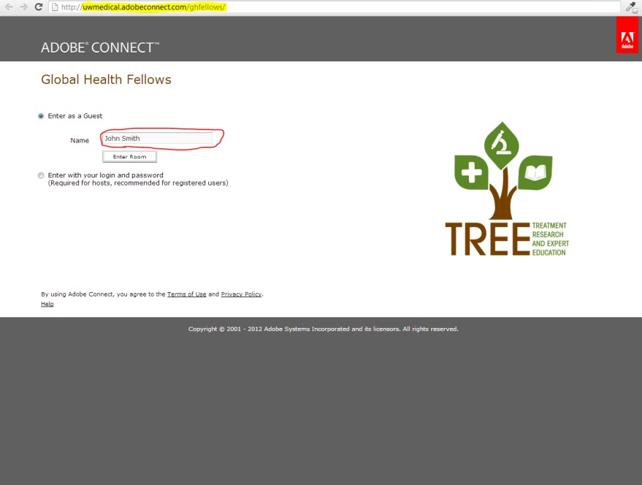

To access Adobe connect go to uwmedical.adobeconnect.com/ghfellows. Type your name in the guest box and click the “Enter Room” button.

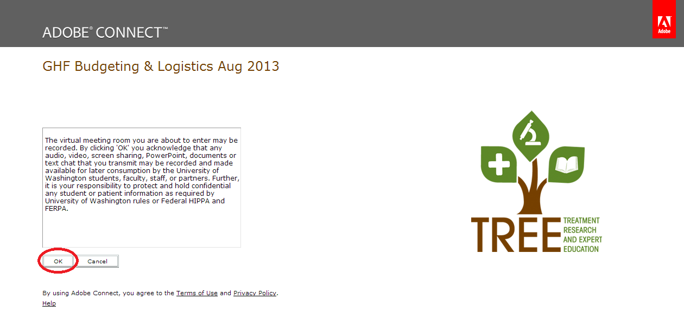

You will then see a message reminding you that the meeting may be recorded, and you should not disclose patient information in an Adobe Connect meeting. Click on the “OK” button to continue.

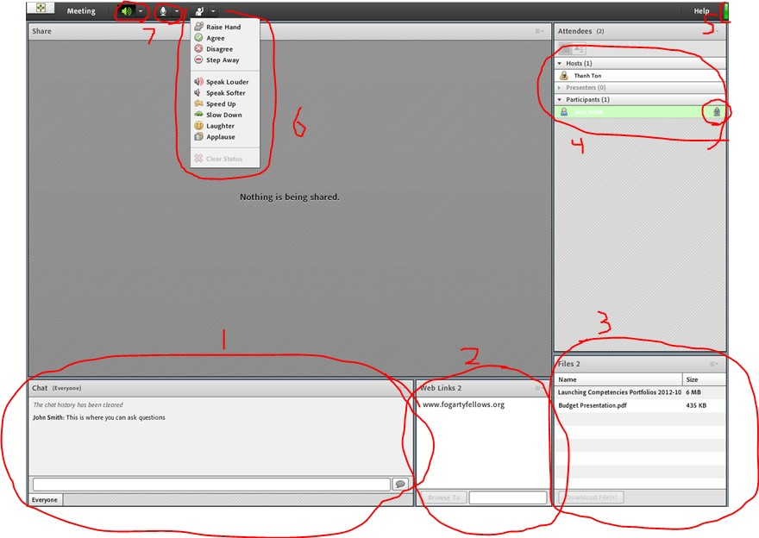

The above image is what you will see once you login to the Adobe Connect session. We have included detailed information about the features of the meeting below. The numbers listed below correspond to the diagram above.

1. This is the chat box where you can ask questions and let the meeting hosts know if you are having any technical problems. Everyone can see the chat history so please do not include information that you do not want others to read.
2. The meeting presenters will upload helpful links and they will be displayed in this box.
3. Any documents that are referenced in the presentation and a copy of the slides will be stored in this box. Simply click on the link, then click the “browse to” button in the bottom left hand corner of the box and the link will open in a different window.
4. This is a list of everyone attending the meeting. During the meeting your microphone will be muted and you will be listed as a participant. If you will be presenting during the meeting, the meeting host will give you speaking privileges in the system and will un-mute your microphone.
5. This green box in the upper right hand corner lets you know if you are connected. If this box is red, that means you have a bad connection, so you might not be able to hear anything or be able to read chat messages. If this happens don’t worry. The meetings are recorded and sent to the group after each live session.
6. If you click on this button at the top of the screen, a drop down menu will let you notify the meeting host that you need something. The most important buttons are the speak- louder/quieter buttons and the speed-up/slow-down buttons.
7. These two buttons control your audio settings. The left button controls your sound. If you cannot hear the presentation, this is the first place to check to see if your speakers are on. The second button will appear when you are given speaking privileges by the meeting host. You need to click here *before* you can speak and this button will activate your microphone.

**Program Website**

Our website is: www.fogartyfellows.org. The website includes important program announcements, information about trainees, and additional resources.

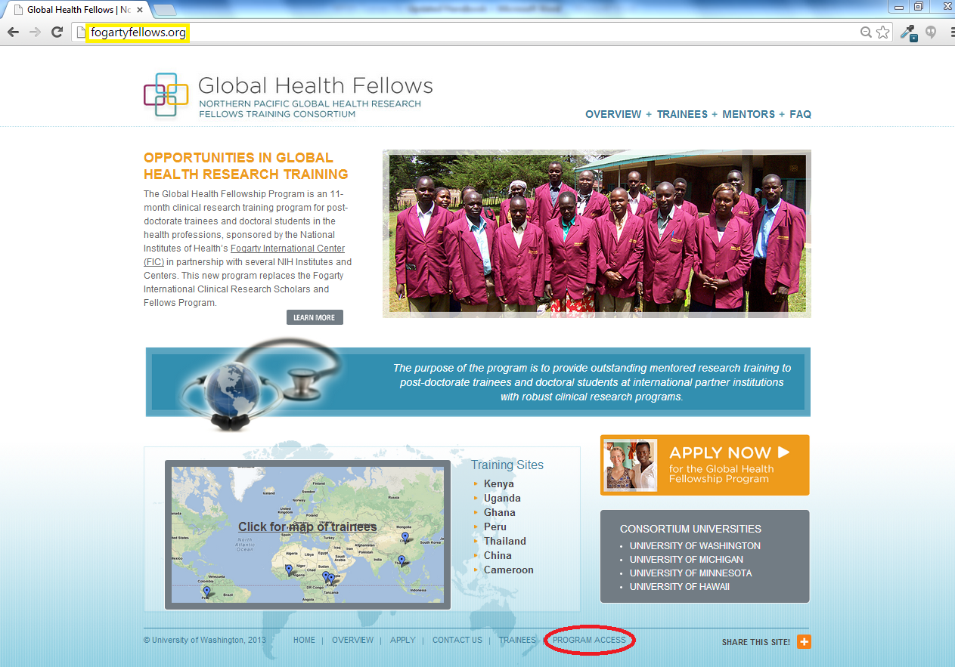

To access internal resources on the website, click the “Program Access” link at the bottom of any of the pages.

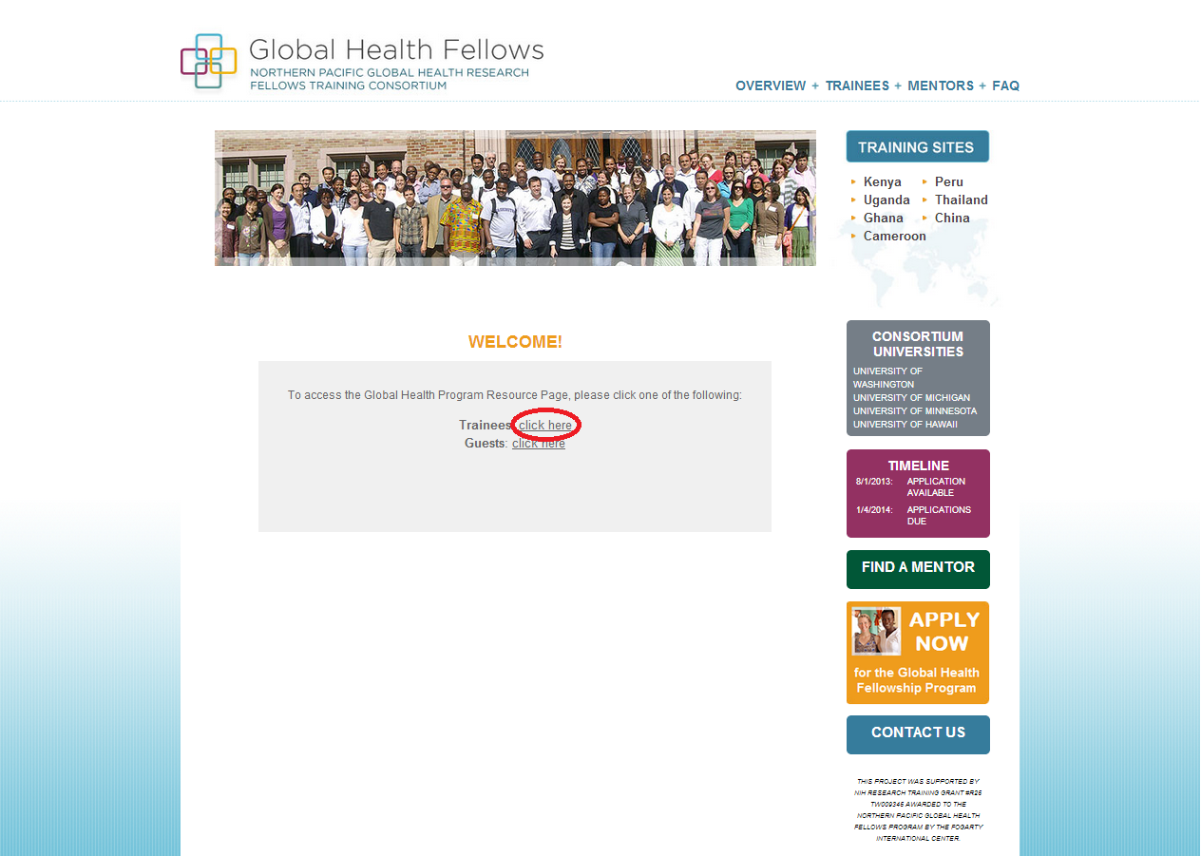

Choose the “Trainees” option by clicking on the accompanying link.

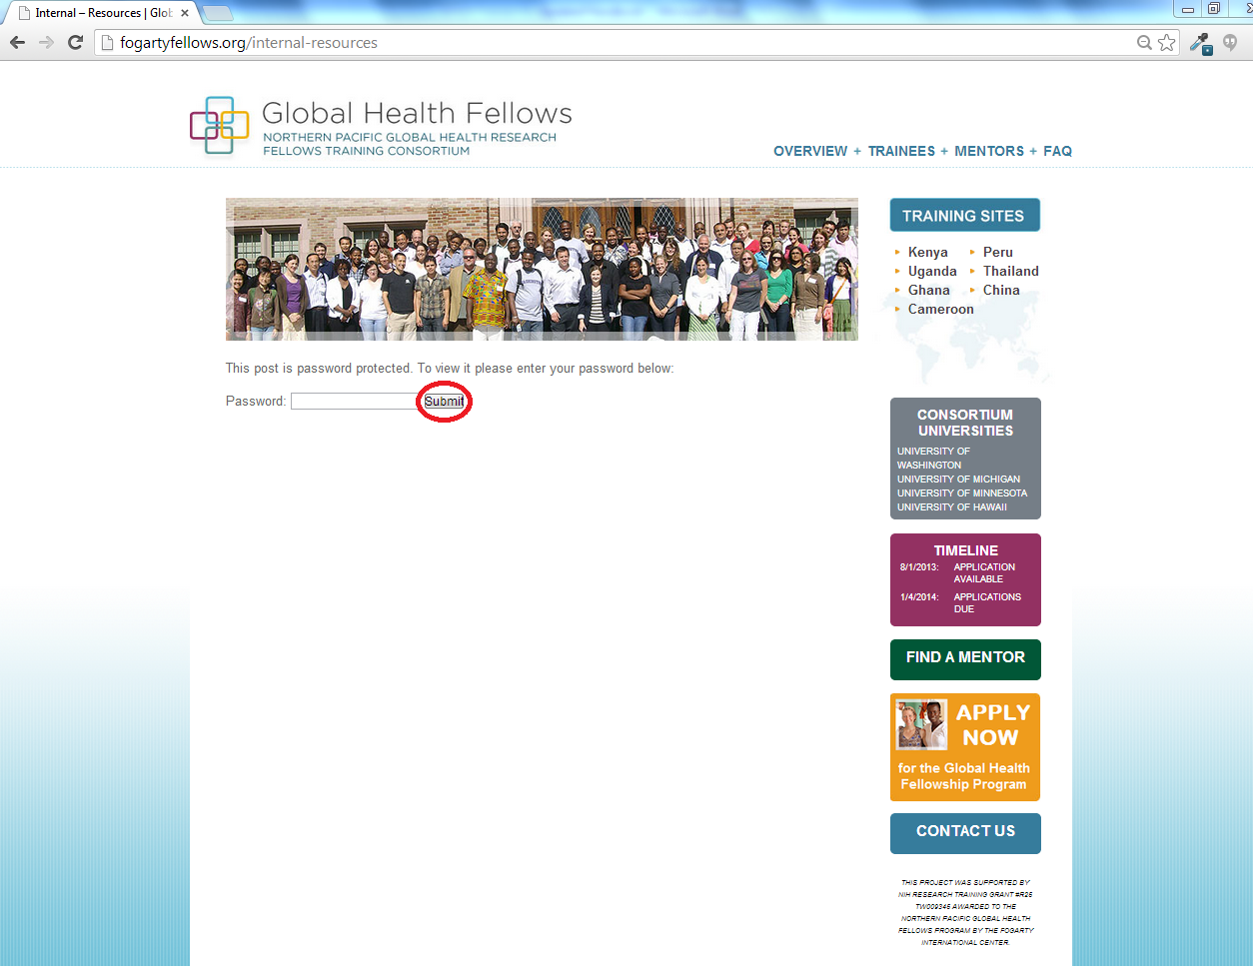

Type in the password: *cohort2012*, click on the submit button, and you’re in!

FOR THE RCR/IRB TAB

**Institutional Review Board (IRB) Approvals**

If your research will involve human and/or animal subjects, you will (most likely) need to obtain IRB approval from your domestic institution and your international site. As another option, trainees may also participate in existing research that already has IRB approval. All trainees must submit a copy of their IRB approvals to the Support Center.

Trainees who are required to submit research protocol forms and IRB applications in a language other than English will receive translator assistance, when needed.

IRB approvals may take months to obtain. Therefore, trainees should begin working on their IRB applications as soon as they are notified of their acceptance into the Fellowship. The Support Center will assist you with this process.

IRB templates and a list of common questions are located on our “Program Access” area of the website ([www.fogartyfellows.org](http://www.fogartyfellows.org)).

FOR THE MENTORSHIP TAB

**Mentorship**

A structured team approach to mentoring will be used for all trainees, with the objectives of providing guidance and feedback on the academic, political and practical nuances of designing and implementing research in the international arena and ensuring each trainee is fulfilling their research and career goals.

We will help trainees develop a mentoring team that includes both domestic and international mentors to help them achieve their research and professional goals. Trainees are expected to establish a schedule for meeting with their mentors; we recommend that they meet on a weekly basis during the first month to develop a research plan, then at least monthly to identify and discuss progress and barriers that may arise.

To ensure trainees and mentors have clear mutual understandings concerning roles, responsibilities, and educational goals, each trainee-mentor pair will be asked to complete the “Mentorship Compact” that is provided by the Support Center.