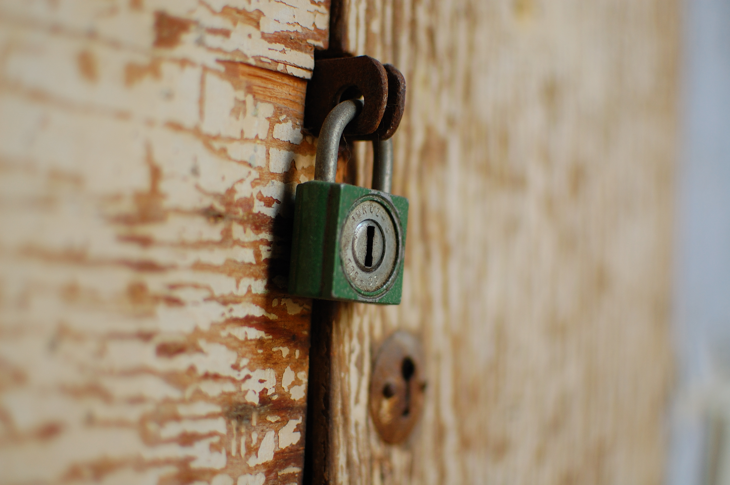

General Safety Briefing

for all Fellows and Scholars

The Fogarty Global Health Fellows Program is committed

to keeping you as safe as possible during your work abroad.

Please read through the following information prior to your departure.

Additional information can be obtained through your embassy website

(http://travel.state.gov/content/passports/english/go/checklist.html)

Fogarty Global Health Fellows

*This list is not comprehensive, but includes items typically unavailable in rural settings.*

**Selected safety and theft-prevention items to bring with you to your training abroad.**

**PERSONAL ITEMS**

**EMERGENCY “GO” BAG**

**HOME/TRANSPORT**

-Money belt

-Extra cash that can be used internationally (Small, $US bills 2007 or newer)

-Personal alarm, whistle or pepper spray

-Anti-theft bags (e.g. PacSafe)

-TSA luggage locks /other locks

-Prophylactic medicine, traveler’s medicines

-Portable cell phone charger (solar/battery)

-Headlamp, flashlight

-Copy of personal documents (passport, credit cards, etc.) and photos of companions

-Optional survival equipment (water purification system, utility tool, etc.)

-First aid kit / travel meds

-Smoke detector

-Rechargeable batteries/charger

-Car “club”

-Door security alarms

-Bike lock & helmet

☐ **Register online** with US Dept. of State Smart Traveler Enrollment Program (STEP) to receive travel alerts and warnings: <https://step.state.gov/step/>

☐ **Provide emergency contact information** to your Fogarty home and international institutions, mentors and family members (see Fogarty Safety Form).

☐ **Know your country** **visa and documentation requirements** and start the application process as soon as possible - especially obtaining letters of support from mentors and appropriate agency staff.

☐ **Make a copy of your passport** and carry photocopies of your passport ID and valid visa at all times. Email a copy to yourself and a family member.

☐ **Make a copy of your credit cards** and leave with a trusted family member in case of a destroyed, lost or stolen card.

☐ **Notify your bank and credit card companies of your travel**: Obtain bank and credit card international contact numbers. Be familiar with ATM usage rates.

☐  **Obtain travel clinic consultation** for appropriate vaccinations and medications at least 6 weeks prior to your departure. Carry a record of vaccinations and copies of prescriptions with you.

☐ **If you plan to drive as an American foreign national** obtain an International Driver’s License from AAA Insurance Company in the USA (and/or local driver’s license). If you choose to seek local licensure in your project country, check with your local administrator about regulations and precautions. <http://www.aaa.com/PPInternational/IDP_IADP.html>

☐ **Know your site**: Read your country-specific safety briefs. Contact your site directors and obtain emergency contacts in country. The *Culture Shock* book series is a good resource on cultural insights and practical logistics for expatriates living overseas (e.g. how to set up a post box, rent an apartment, obtain documentation).

☐ **Prepare safety and theft-prevention equipment:** See table to left for ideas. Consider building a “go-bag” prior to your arrival in country. For a complete list, visit: <http://nairobi.usembassy.gov/gobagitems.html>

# Checklist: Before You Travel

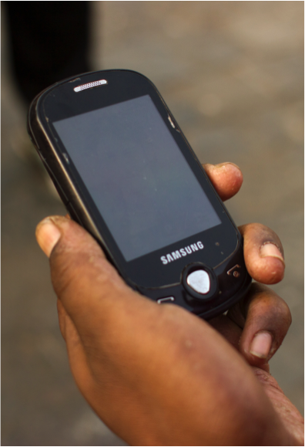

Establish a closed Facebook group, such as a “Neighborhood Watch” to keep others informed of local warnings, notices, incidents, or security concerns.

☐ **Notify your mentors** in US and in country of your arrival and any new contact info (i.e. local phone, cell phone, and address).

☐ **Discuss emergency protocols** and phone trees with your in-country colleagues, including:

* Local contacts in case of emergency
* Preferred hospital
* Embassy security officer contact
* Police stations
* Trusted taxi numbers

☐ **Connect with the US Embassy** (or your Embassy if not a U.S. citizen) for official safety briefing and direct. In certain countries, Fogarty may fall under the US Embassy, Office of Cultural and Educational Affairs as Fulbright-Hays or Title VI grantees/fellows umbrella for embassy access and services. Enter your emergency and embassy phone numbers directly to your phone contacts: (http://travel.state.gov/content/passports/english/emergencies.html)

☐ **Carry in-country contact** information and ID (photocopy or original) on your person, in case you are in an accident.

☐ **Get to know the informal support network**: expatriates and in-country colleagues are crucial for navigating local systems and providing personal support if an emergency occurs. Obtain the numbers of local colleagues and any expatriates in the area who may be able to provide support in case of emergency. Discuss safety concerns with these individuals and learn about their safety experiences in country.

*Your country support network may include fellows/scholars in your country and other trusted community members. Determine if your site has existing alert systems and join them.*

**Mobile Phone: Whatsapp**

Establish a free *Whatsapp* group to notify others quickly about security issues via an application for smart phones. This notice board serves the function of a phone tree for trainees, providing a way to be contacted and respond.

Create Google Group to easily contact others about security issues via an email based platform. This is also ideal for sharing safety guides, tip sheets, and other documents of interest.

**Google Groups**

**Facebook**

**Additional Security**

**Communication Ideas**

# Checklist: When You Arrive in Country

Safety on the Road:

Motor Vehicles

* Fogarty Fellows **may not ride on or operate motorcycles or scooters.**
* **If you drive**, consult your country’s specific guidelines on road safety, laws, and insurance.
* **Use trusted taxi drivers** both day and night. Beware potential dangers of using taxis that carry other passengers or staff you don’t know. Always lock doors and roll-up windows.
* **Wear seatbelts** to prevent serious injury in a car accident.
* **Keep valuables out of sight while driving, and while parked.** Travel with items in the trunk/boot, on the floor, or under the seat (good for laptops). Minimize leaving valuables in the car. If you must leave valuables, rearrange them before your car is parked or doors are opened… not afterwards, when you may draw attention.
* **Ensure vehicle doors are locked** at all times, and windows are rolled up. **Carjacking** is a concern day and night. Gate entry to your home or other locations are vulnerable places where car-jacking frequently occurs; consider systems that allow you to enter quickly and reduce waiting time (e.g. calling your guards to prepare gate) and be watchful of suspicious vehicles before you enter. If you are followed, make another lap, or drive to a public space such as police station. Review and be familiar with the US State Department document regarding carjacking: http://www.state.gov/m/ds/rls/rpt/19782.htm

Safety at Home

* **Inquire about safety features while selecting housing:** Consider fire-safety, adequate security fencing and lighting, guard service, etc. Your local mentor, colleagues, or alumni are great resources.
* **Create a “safe haven”** in your home, in case of home invasion. Ensure the bedroom door or bedroom gates lock at night. You should also keep a phone, keys, first aid kit, and your “go bag” here.
* **Set expectations regarding who is allowed to enter your home** (staff or visitors), and consider who is the first line of defense at point of entry. Be cautious about admitting people you don’t know well, especially if you are alone or of the opposite sex. If you have guards, house staff or roommates, ask them to notify you before they admit visitors.

Safety on the Streets:

Pedestrian Safety

* **Determine if walking is safe** in your neighborhood; if not, get appropriate transport such as a taxi or a shared ride.
* **Safeguard cash and electronics on the streets,** by keeping computers, cameras, and mobile phones out of sight. Snatch and grab theft occurs. Be especially careful in coffee shop environments or while jogging with music.
* While these guidelines are helpful at all times of day, **be especially vigilant at night.** It is safest to reduce night and pedestrian travel as much as possible. The best option is to take a taxi or shared ride. However, If you walk at night:
* *Look down* for dangerous obstacles while walking down paths and roads (holes, open sewage drains).
* Be as visible as possible to avoid being hit by cars, especially if sidewalks are unavailable.
* Inquire if night escorts are available.
* If going home at dusk or night, alert your trusted home gate guards (if night guards have phones) to receive you immediately when you arrive to reduce vulnerability at gates, when events such as carjacking and robbery may occur.

**Additional tips on driving or transport**

**may be available in your country**

## Vestibulum ante ipsum primis in faucibus orci luctus et ultrices posuere cubilia Curae.

Proin nulla nunc, tempor quis, feugiat at, dignissim in, dui. Praesent sollicitudin pede ac lacus. In massa. Nullam congue, nulla iaculis commodo rhoncus, mauris ipsum ultricies tortor, a auctor ipsum justo ac dui. Integer et nulla. Nulla faucibus purus id est fringilla porta. Quisque nec velit id libero dictum facilisis. Cras purus neque, viverra id, aliquam imperdiet, interdum in, turpis. Sed commodo, sem a dapibus nonummy, eros erat dictum dui, ut aliquet nulla sem id lectus.

### Praesent ante. Vivamus eget tellus.

Curabitur eros. Sed tincidunt tellus vel leo. Ut sodales, magna at consectetuer mattis, eros felis bibendum tortor, id consectetuer lorem nisi vel pede. In neque. Donec ac sapien. Quisque varius dui non orci. Nunc sed felis. Aliquam vitae justo vel nibh facilisis suscipit. Class aptent taciti sociosqu ad litora torquent per conubia nostra, per inceptos hymenaeos. Duis eget pede. In hac habitasse platea dictumst.

Proin enim. Nunc ac ligula sit amet felis porta tempor. Morbi dignissim dictum purus. Donec nonummy neque ut ante. Donec malesuada, nulla a sodales venenatis, tortor ligula egestas lorem, vel auctor sem ante sed magna. Nulla malesuada leo ultricies ante. Aliquam sit amet lacus vel velit aliquet laoreet. Nullam sed neque a tortor lacinia tempus. Nullam sed tellus.

Curabitur sem tortor, iaculis at, venenatis eu, sodales tincidunt, lorem. Quisque scelerisque. Cras dapibus nisl a tellus. Pellentesque ultrices imperdiet nulla. Class aptent taciti sociosqu ad litora torquent per conubia nostra, per inceptos hymenaeos. Donec gravida orci ut velit. Aenean elementum quam in metus. Morbi convallis mattis metus. Donec felis urna, tempor eget, commodo at, nonummy id, mi. Donec semper ligula et diam. Suspendisse tempor, ligula eget viverra placerat, justo nibh malesuada velit, ullamcorper congue felis urna et nunc. Duis id nulla.

### Aliquam euismod lacinia eros.

Sed blandit dapibus quam. Sed varius, sapien ut egestas tincidunt, purus enim pretium metus, eget dignissim nunc lorem in pede. Nulla et tellus vitae diam sollicitudin porta. Vestibulum scelerisque dui eu mauris. Vivamus consequat sapien vel erat. Nulla rutrum ornare mi. Aliquam varius. Class aptent taciti sociosqu ad litora torquent per conubia nostra, per inceptos hymenaeos. Pellentesque ut augue et massa aliquam hendrerit. Vestibulum nibh massa, sodales sit amet, faucibus eu, congue nec, tellus. Suspendisse eros arcu, vulputate sed, aliquet ac, egestas nec, purus. Morbi at nunc eu lectus pharetra sagittis.

Proin posuere risus. Duis arcu orci, porttitor dapibus, ultrices in, dictum eu, lacus. In sit amet nisl. Mauris nec ipsum. Donec feugiat, velit consectetuer cursus ultrices, neque orci eleifend lorem, sit amet dignissim lorem leo vitae nisl.

## IF YOU BECOME A VICTIM OF AN ACCIDENT OR CRIME…

* Be cautious about any admission of fault. There may be potential dangers if a crowd starts to gather.
* First, ensure you are in a safe place.
* Contact your health facility if you need medical attention. In cases of sexual assault, seek care immediately.
* If you attend a health facility, bring someone with you if possible to serve as your advocate and take care of tasks such as payments, prescriptions, and ensuring continuity of care.
* Contact your embassy, or local security warden – they may be your best local resource. Contact them immediately, especially in time-sensitive situations (e.g. traffic accident, legal trouble).
* Contact your local law enforcement or authority (best with representation from your embassy or someone local who can be your advocate).
* Contact and inform your mentors and Fogarty coordinators.
* Communicate to others about the incident soon after the event. Alert others in your neighborhood immediately to ask for help if needed, and to warn others about potential multiple attacks in the same night.
* Document the event in as much detail as possible as soon as you can. Photos are often helpful. See box below for important questions.

### Security Incident Questions:

1. Day, time, location of the event
2. Who was involved as the victim (s)
3. Who was involved as the perpetrator(s), if applicable?
   1. Gender
   2. Age
   3. Physical description (height, body build, hair/eye/skin color)
   4. Language/accent
   5. Any other identifying factors (clothing, tattoos, etc.)
   6. Description of vehicle and/or license plates
4. What was the context of the event?
5. Describe the sequence of events
6. Who was notified about the event, and when?

